Name : MUHAMMAD MUBASHAR ALI

Student ID : BSIET02213012

Subject : object Oriented Programming .

Lab : 08

Example # 01

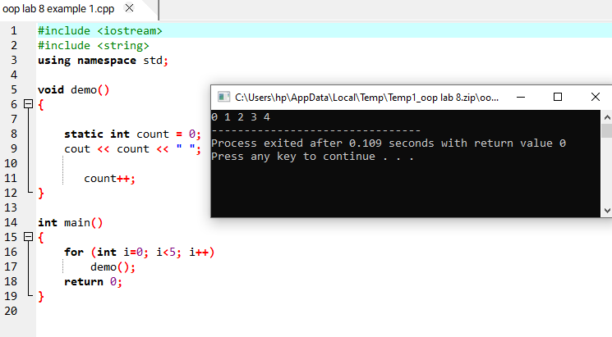

Example # 02

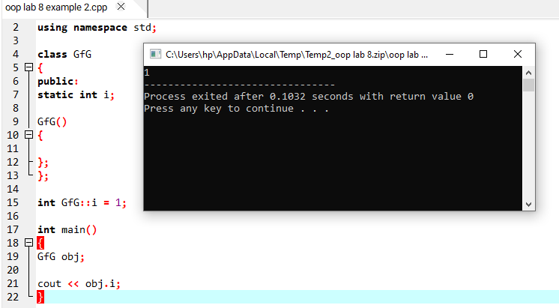

Example # 03

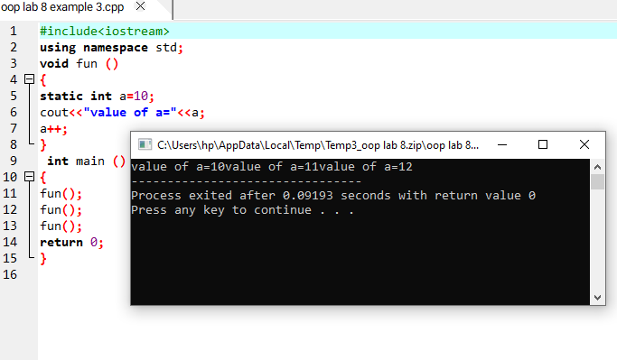

Example # 04

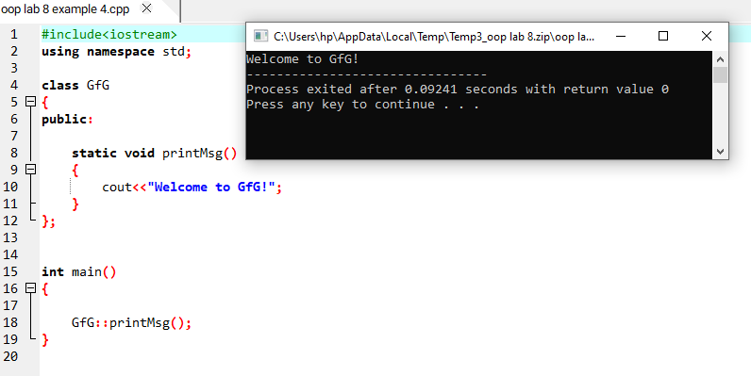

Example # 05

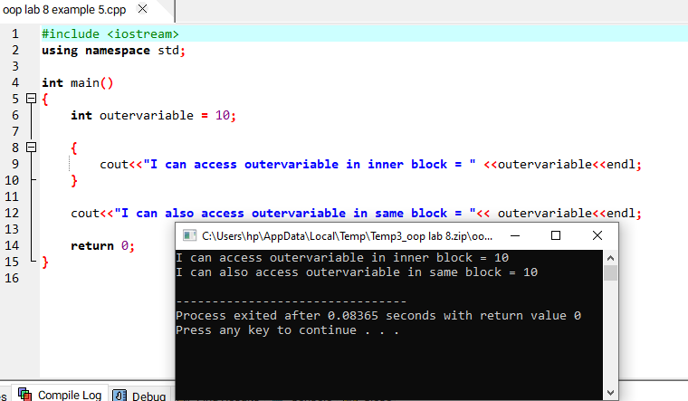

Example # 06

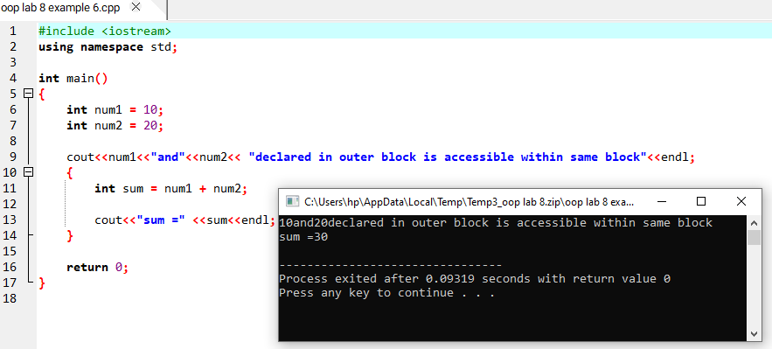

Example # 07

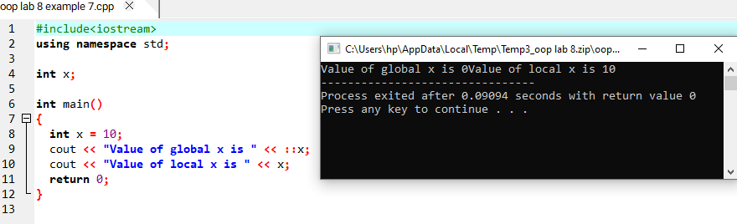

Example # 08

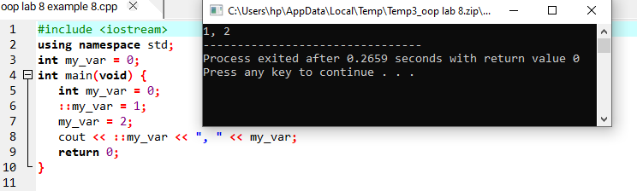

Example # 09

